THE HEAD-TURNING JAW-DROPPING BIG IDAHO® POTATO TRUCK IS BACK ON THE ROAD FOR ITS 7TH NATIONAL TOUR
In 6 months the truck will travel 28,000 miles and visit more than 60 cities

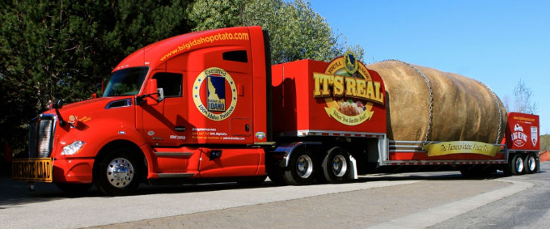

Boise, IDAHO (May, 2018) -- Back by popular demand, the world’s largest potato on wheels is traveling across the country promoting Idaho’s most famous agricultural product, the Idaho® potato. While on its journey, the Big Idaho® Potato Truck will help dozens of charities better serve their communities through its charitable program, “A Big Helping.”
“The Big Idaho® Potato Truck has become the cornerstone of the Idaho Potato Commission’s marketing program,” explained Frank Muir, President & CEO, Idaho Potato Commission (IPC). “By promoting the truck in our national advertising campaign, participating in events with hundreds of thousands of attendees, and making stops at key retail and foodservice operations, we’ve been able to engage millions of consumers of all ages across the country.”
During its six-month tour, the Truck will travel approximately 28,000 miles and be heralded as the main attraction in several parades and festivals across the country including Thunder Over Louisville (KY); the National Memorial Day Parade in Washington, D.C., and NASCAR Poconos Raceway
The Tour

There are numerous ways for folks to follow the 2018 Big Idaho® Potato Truck Tour and plenty of opportunities to see it in person…
- BigIdahoPotato.com is the Truck’s official website that has a calendar listing all the Truck’s stops.
- Potatotracker.com provides a live feed of the oversized spud, allowing visitors to see where it is any time of day.
- Social media channels will continue to provide spud lovers with direct interaction with the Tater Team, the threesome that travels with the Truck, and the latest news on the tour:
  - Facebook: Big Idaho Potato Tour
  - Instagram: @bigidahopotato
  - Twitter: #bigidahopotato
  - Vine: bigidahopotato
The Tater Team
The Tater Team is made up of three people who love to travel - especially in a giant spud! Kaylee, a Boise State University Alum, is on board for her very first tour and is anxious to travel alongside her best friend. Jessica, the best friend and University of Idaho Alum is an outgoing Boise native who brings fun to this #TaterTwin duo. “Ron the Driver” (#TaterToter) is taking a hiatus from his retirement to have fun with this big Idaho spud.
The Truck

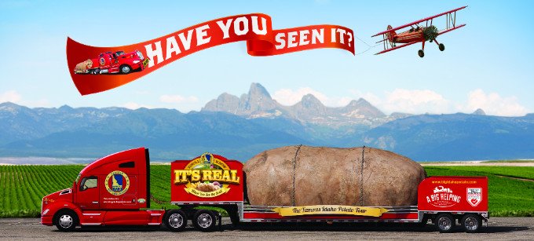
The Big Idaho® Potato weighs more than 4 tons (the equivalent of 32,346 medium-sized Idaho® potatoes). After being seen by hundreds of millions of Americans, the most frequently asked question is still, “Is it real?” We’ll never tell…but if it is, the Big Idaho® Potato:
- Would make 20,217 servings of mashed potatoes… pass the gravy!
- Could make almost 1 million (970,380) French fries!
- Would weigh 802 times more than the largest potato ever grown, which clocked in at 11 pounds.
To date, the Truck has visited 48 states (all but Hawaii and Alaska), traveled through 7,000+ towns/cities and traveled 140,000 miles since its 2012 launch celebrating the 75th Anniversary of the IPC. The Big Idaho® Potato Truck was built by Chris and Sharolyn Schofield of Weiser, Idaho with the help of a few specialized contractors. The Truck took a full year to design and build.
A Big Helping
The Big Idaho® Potato Truck Tour has always had a charitable component to it, and now in its second year, “A Big Helping” is the Truck’s “personal” way of assisting local charities across the country. During its seven-month tour, the Truck’s management team will identify local charities to receive a $500 donation via a Signature Board that’s set up at the events the Truck visits. Past recipients have included food banks, children’s hospitals and animal shelters.
“We already know that the Truck brings smiles to people wherever it goes but now it’s also helping people and that feels pretty good,” said Muir.
# # #
About the Idaho Potato Commission
Established in 1937, the IPC is a state agency that is responsible for promoting and protecting the famous “Grown in Idaho®” seal, a federally registered certification mark that assures consumers they are purchasing genuine, top-quality Idaho® potatoes. Idaho’s growing season of warm days and cool nights, ample mountain-fed irrigation and rich volcanic soil, give Idaho® potatoes their unique texture, taste and dependable performance that differentiates Idaho® potatoes from potatoes grown in other states.

